Tibet travel tips
Italian scientists came to the conclusion that in the result of quite severe weather conditions there appeared some untouched places on our planet. And the most desert area on the globe is the spot in the mountains of Tibet. It’s situated at the height of more than seventeen thousand feet. The road here takes no less than 21 days. This terrain is very difficult because of the bad landscape. However, let’s read this list of places that are more accessible and quite fascinating:
- Mountain Kailash
The sacred mountain, which is still considered as an unsubdued top, is situated in a remote locality of western Tibet. Also, in every tract it is said that the mountain can keep only gods and the others are to be thrown off. Moreover, millions of pious people are against its conquest and they’re supported by U.N.O. For the reasons given above tourists can’t climb this mountain.
Actually it is the tetrahedral pyramid and its sides point to the cardinals. The cupola is covered with ice and southern wall has a straight crack which turned into a cleft. People believe that those who walk around this mountain will get an absolution.
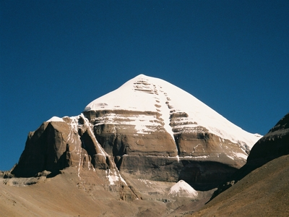

- Potala Palace
The Potala Palace, winter palace of the Dalai Lama since the 7th century, symbolizes Tibetan Buddhism and its central role in the traditional administration of Tibet. The beauty and originality, rich ornamentation and harmonious integration in a striking landscape that is what you’ll see if you visit this marvelous place.
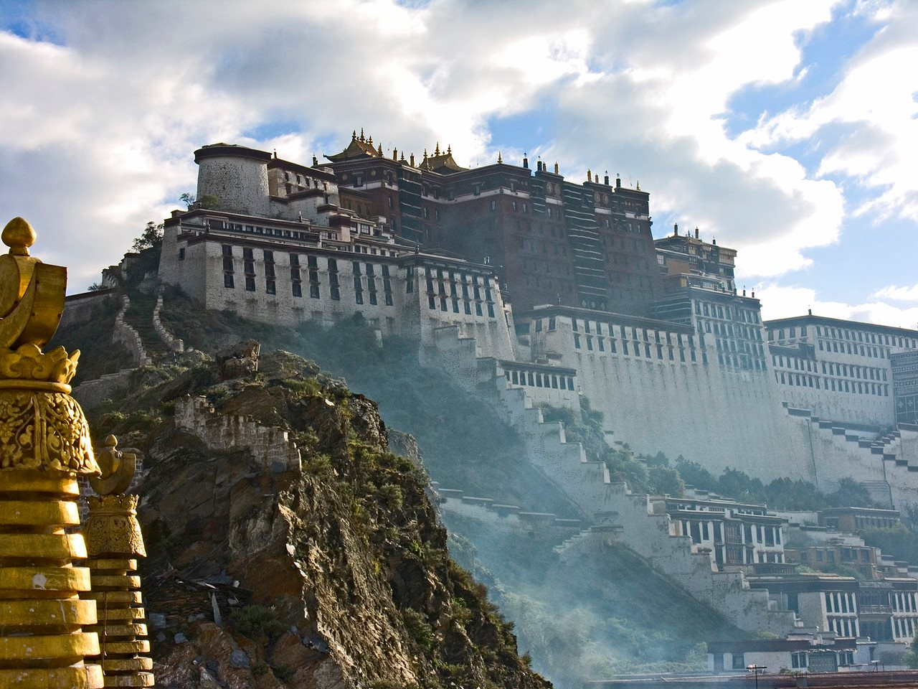
- Old Yak Bazaar
This is an alternative trading company bringing you the best in handcrafted, fair trade and upcycled products from tucked away back alley workshops across the world. They actually have a map that shows where their products are made, and links to organizations they partner with, so you know exactly where your goodies are coming from.
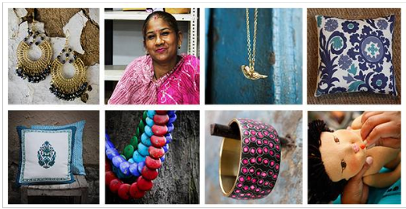
Don’t buy souvenirs if you don’t know their appropriation, especially, if they have occult nature. Looking through the market rows, your eye can be drawn by some interesting things, but be careful, you can choose very ancient accessory which went through the many hands and was used in rites. Such things can play a trick on you in a very spiteful way.

- Jokhang Temple
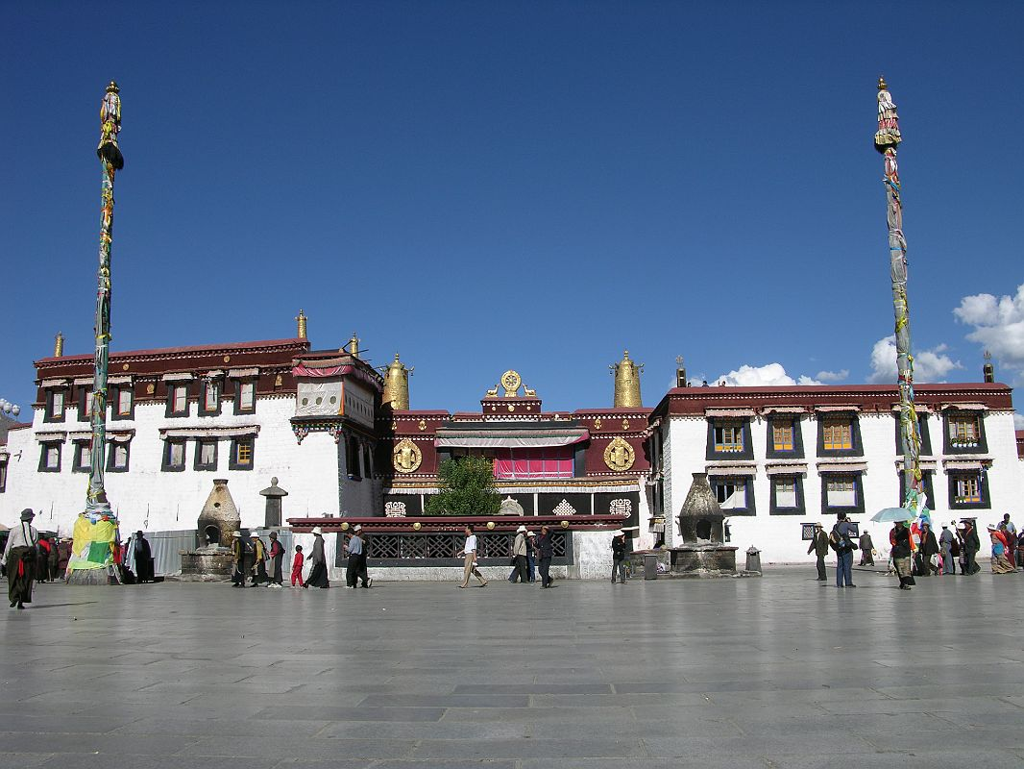
The Tibet’s first Buddhist temple is located on Barkhor Square in Lhasa. It was first constructed by King Songsten Gampo probably in 642. This temple has remained a key center of Buddhist pilgrimage for centuries. It was sacked several times by the Mongols, but the building survived. In 1966, the monastery was sacked and desecrated by Red Guards during the so-called Great Proletarian Cultural Revolution. Thousands of Buddhist scriptures were looted and burned.

- Rongbuk Monastery
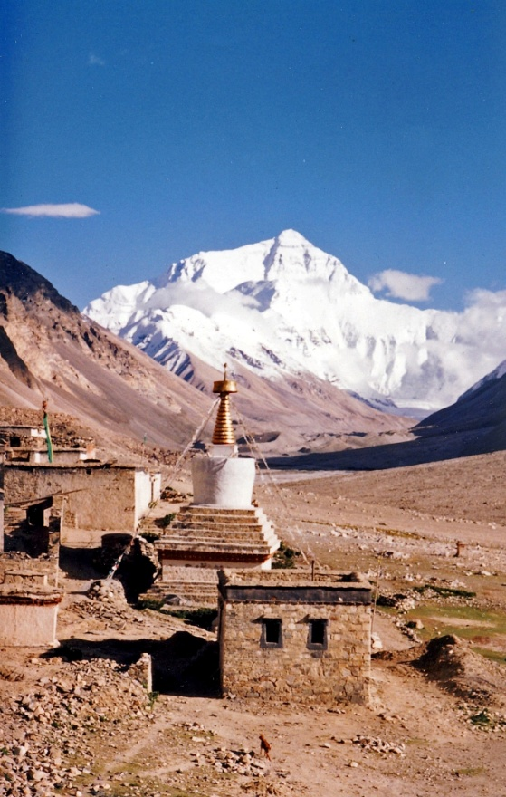
It's a Tibetan Buddhist monastery which lies near the base of the north side of Mount Everest. Rongbuk is claimed to be the highest monastery in the world. It was destroyed completely in 1974 but in 1983 it went through the reconstruction. An amount of books and costumes were sent to the Tengboche monastery but all of them were lost because of the conflagration there. Nowadays tourists are allowed to visit only two floors out of five.
There is a hotel and restaurant not far from the monastery. If you go a little bit further, you'll see camping of climbers.

